

**School of Information Technology & Engineering**

**Second Review Report**

**Software Configuration Management**

**(SWE503)**

**Faculty: Prof. Jagadeesh G**

**Slot: B2+TB2**

**EPOS MANAGEMENT SYSTEM**

**Team Members:**

**13MSE0051 (C.lokesh reddy)**

**13MSE0367 (K.Ranjit kumar)**

**CONTENTS**

**1.0 INTRODUCTION**

1.1 Purpose

1.2 Scope

1.3 Definitions

1.4 References

**2.0 SCM MANAGEMENT**

2.1 SCM Organization

2.2 SCM Responsibilities

2.3 Relationship of SCM to Software Process Life Cycle

2.4 Interfaces to Other Organizations on the Project

2.5 SCM Responsibilities of the Organizations

**3.0 SCM ACTIVITIES**

**3.1 Configuration Identification**

3.1.1 Identification of Configuration Items

3.1.2 Naming Configuration Items

3.1.3 Acquiring Configuration Items

**3.2 Configuration Control**

3.2.1 Change Initiation

3.2.2 Change Evaluation

3.2.3 Change Management—Approval Process

3.2.4 Change Implementation

3.2.5 Change Control Boards (CCBs)

**3.3 Configuration Status Accounting**

3.3.1 Identifications of Information Needs

3.3.2 Information-Gathering Mechanisms

3.3.3 Reports, Their Contents, and Frequency

3.3.4 Access to Status Accounting Data

3.3.5 Status Accounting 'Information Dissemination Methods

3.3.6 Release Details

**3.4 Configuration Auditing**

3.4.1 Audits to Be Performed

3.4.2 CIs under Audit

3.4.3 Audit Procedures

3.4.4 Audit Follow-Up Activities

**4.0 SCM SCHEDULES**

**5.0 SCM PLAN MAINTENANCE**

**6.o SCM TOOL**

**1.0 INTRODUCTION**

**1.1 Purpose**

This document is simply known as Software Configuration Management Plan. Where it provides a template for the easy understanding and guiding the staff who are involved in the project. It is mainly for easier assistance for the management activities going on in the project. It is also helpful for the people who are working in the background on the software for understanding the system.

**1.2 Scope**

It is the **Electronic Point of Sale** generally used in retail operations to itemize and summarize sales. The program will be easy to use, reliable,secure and also will be fully customizable by the administratorss.

**1.3 Definitions**

**GPS: GLOBAL POSITIONING SYSTEM**

* **The ability to have security, ease of use, and power over how they want the application to function will be our selling point.**
* **Because of the quick employee turnover rate, our system will be different because the interface will fairly intuitive. It will be easy to use.**

**HTML: HYPER TEXT MARKUP LANGUAGE**

These are used for designing a web page for our systems user interface which can be accessible globally for booking a cab in our project scenario.

**JSP: JAVA SERVER PAGES**

These are extensions for the interface pages such are said as back end of the system. In which they contains of the connections and logics of the system working on.

**SCM: SOFTWARE CONFIGURATION MANAGEMNET**

This is the management of the project activities for the versioning/changes of the software.

**CCB: CHANGE CONTROL BOARD**

This is a committee in SCM where this team takes the decisions about the proposed changes by checking the use and feasibility of the changes before the implementation.

It is a committee that makes decisionsregarding whether or not proposed changes to a

**1.4 Glossary**

**Baseline**: The point at which a document or other object becomes a configuration item.

**Configuration item:**  A document or other object placed under configuration control.

**2.0 SCM MANAGEMENT**

This section of the plan documentcontains information about the SCM team and organization, and also allocation of responsibilities to the teams and individuals what they have to perform for implementing or developing or maintaining a system.

**2.1 SCM Organization**

The organizational structure will be explained in this module. It describe the structure of the SCM team of the project “EPOS MANAGEMENT”. It also tells how it fits into the organizational structure with respect to others. All the activities in the SCM are maintained by the baseline form created for the project organization.

**2.2 SCM Responsibilities**

This part of document gives a detail information about the duties and responsibilities of the persons involved in the working of SCM activities for developing out project “EPOS MANAGEMENT”.

* To maintain each and every configurational change records for easy retrieval of history.
* The Project administrator take care of the maintenance of the software internal updates for maintaining good software solution.
* SCM team are responsible for selecting the CCB team members who handle change requests.

**2.3 Relationship of SCM to Software Process Life Cycle**

This part explains and relates the SCM activities to the Software process Life cycle. That is to explain in which Life cycle stage what are the activities are to be performed.

There are four basic SCM activities

1. Configuration Identification
2. Configuration Control
3. Configuration Status accounting
4. Configuration Auditing

Software Development Life Cycle stages

1. **Requirements gathering**: In this phase, Configuration Identification is involved directly for identifying the items required for changes.
2. **System design**: In this phase, Configuration Control and configuration Identification are used for the changes going to be implemented in the project.
3. **System development**: Here only configuration status accounting is going to be related as it is the activity show about the system changes status ,that means what has been updated and done on the system after change request is processed.
4. **System testing**: It is related directly to the Configuration auditing which means checking of the software functionality after the change request has been completed successfully.

**2.4 Interfaces to Other Organizations on the Project**

This part is totally about how the SCM team will interact with the other organizational teams involved in the project such as, project testing, QA and project management teams.

SCM team directly contacts the QA team, to check the quality of the software parallel while the change request is processing.

Testing process team is also involved directly to the SCM to check whether is software performance is good or not.

Project management team also related to the SCM team which is the main part of the project development team.

**2.5 SCM Responsibilities of the Organizations**

` This part describes about the responsibilities of the contractor or vendor who are related or responsible for carrying out the SCM activities.

Here the vendors are requested for the functions which public want to avail in the software system. And then the activities are planned accordingly to done with the change request processed by the team of SCM for the new change requested in public interest.

**3.0 SCM ACTIVITIES**

This part of document is used to identify tasks and functions required for the configuration management of system as per the scope of the project plan.

**3.1 Configuration Identification:**

It is the process of identifying the physical and functional characteristics of the configuration items of a project we are going to work on. And also involves of naming and documenting the configuration items.

In general, Configuration items are the items which are to be change for updating or moderating the software.

3.1.1 **Identification of Configuration Items**

There are items of the project which can be changed for the further updating features in the software.

Here the configuration items are:

1) **System specification:**

* + The system is built in such a way to make easiest mode of issuing goods to the customers.

**2) Software Project Plan:**

* + To have security, ease of use, and power over how they want the application to function.

**3) Requirement Specification:**

* + Ram=2gb
  + Processor=intel core i5
  + Harddisk=100gb
  + Platform=html+javascript

4) **Preliminary user Manual:**

* + Here user manual will be made available so that they can have an overview of how to use the system.

1. High level design:

It is the front end of the software for access of the features in the software and can also said as the user interface pages of the software.

Here they are implemented using PHP, HTML.

1. Low level Design:

It is the back end processing of the project system, how it functions for getting the requests to process.

They are JavaScript and Java Server Pages (JSP).

1. Database:

Here the database used is ORACLE for the maintenance of the data of the booking cabs and for the history management and the fares database how to be charged.

**5)Design specification:**

* + **Data Design:**
    - Here data is gathered,preprocessed and stored in database that will be maintained under highly secure environment.
  + **Architectural Design:**
    - System is built on webbrowser using html and javascript.
  + **Module Design:**
    - Here each and every module has its own interface as each one has its own task to perform.

6)**Source code listing:**

* + The code used for buliding up this system is listed here.

7)      Test plan and procedure

* + a)      Software problem report
  + b)      Maintenance requests
  + c)      Engineering change orders
* Test cases and recorded results

8)      Operation and Installation Manuals

9)      Executable

10)  Database Description:

* + Here we are using microsoft.oledb (provided by sun microsystems)for connecting the interfaces with databases.

11)Built user Manual

12)Maintenance Documents

3.1.2 **Naming Configuration Items**

All the above identified configuration items are named into the coded language for the surety reasons so that only the persons involved in development.

Now the configuration items are

CI1- High level design

CI2- Low level design

CI4- Databases

3.1.3 **Acquiring Configuration Items**

In this part the identified configuration are been baselined and loaded for making the further changes in those items for developing the software. Those all will be stored in the controlled library for easy access of the files.

**3.2 Configuration Control**

In this section of the document, it show the change management processing on the configuration change in the project. For managing this activity there is special team is allotted that is known as CCB (Change control Board).

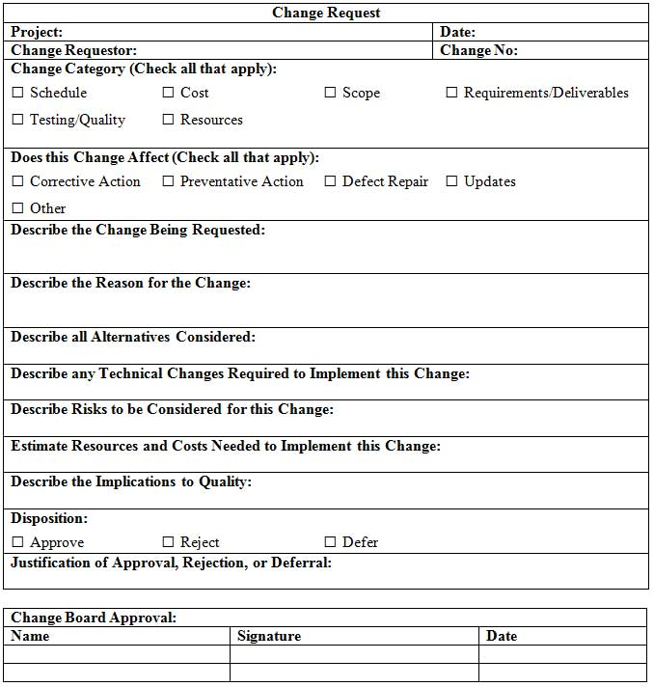

3.2.1 **Change Initiation**

A new enhancement in the feature of software is explained and a request will be initiated.

Here the change initiated is “to enhance the user interface for easy understanding of the features”.

3.2.2 **Change Evaluation**

The requested change will be evaluated by the team members of CCB such as is it can be implemented or feasibility analysis will be done and a report will be generated for the request status of the change.

3.2.3 **Change Management—Approval Process**

After analysing the report of the evaluation process, the CCB team will decide is it worth the change. If it is worth to change, then the request will be processed and developers will start working on the requested upgrade. If not worthy to upgrade the request will be rejected and will not be processed to the next level of the developing activity.

Here the change request is approved as it is feasible and worth the change as by making the change the user number will increase.

3.2.4 **Change Implementation**

As the change request is approved and now in this part the team of the project who will work on it will be listed and work is allotted for them for implementing the change processed.

3.2.5 **Change Control Boards (CCBs)**

This is the team which makes the decision on the change requests and maintains the configuration management in an ordered process for making a change. In this team, leader and several developers and testers will also be available.

**3.3 Configuration Status Accounting**

This section takes the part of reporting and recording the status of the configuration items that are undergoing the change process.

3.3.1 **Identifications of Information Needs**

In this part the information about the persons who needs the updates about the changes and why it is needed for them is all listed out.

In general, the updates about the system processing will be informed to the CCB and SCM team leaders and also the vendors and the project leaders.

3.3.2 **Information-Gathering Mechanisms**

Ideally, the information should be entered into the configuration management database by the initiators of the SCM activities rather than by the SCM person chasing the activities and updating the status accounting data.

* Configuration verification and audits establish that the performance and functional requirements defined in the configuration documentation have been achieved by the design and that the design has been accurately documented in the configuration documentation.
* Here we follows 3 levels of TRR (Test Readiness Review)
* **Development TRR** – successful completion of unit testing of a given application
* **Project TRR** -successful completion of software integration test SIT of a given application
* **Enterprise TRR** -successful completion of functional validation test (FVT) of a given application

**Standard used:DOD-STD-2168**

* This standard contain requirement for the development, documentation and implementation of a software quality program.
* Planning for conducting evaluating of the quality of software, associated documentation, and related activities and follow-up activities also.

3.3.3 **Reports, Their Contents, and Frequency**

In this part many reports about the change recording will be made for the understanding of the team in the future. And reports are more frequently updated for the status tracking of the project progress.

3.3.4 **Access to Status Accounting Data**

The status will not be processed and calculate for generating the reports every time. It will be done once if any of the limit of modification are done in the document report. If the system is computerized then the parallel query system for status accounting is provided.

3.3.5 **Status Accounting 'Information Dissemination Methods**

It says about how the reports will be submitted and accessed by the higher authorities who are able to check the status of the project.

3.3.6 **Release Details**

It contains the details of the change in the project and for whom the change has been done and the request and pairing information needed for running the system successfully.

**3.4 Configuration Auditing**

This section provides the information of what types of audits that should be done on the project, this is a requirement evaluation process and defines the auditing authority.

3.4.1 **Audits to Be Performed**

The types of audit which can be done on the project are listed here, they are

1. Internal Audit: It is functionality testing of the requirement listed in the change request.
2. External Audit: It is non-functional testing done on system to check the performance of the system.

3.4.2 **CIs under Audit**

Here the CIs that are to be audited are the

1. High level design

3.4.3 **Audit Procedures**

In this part, the procedure to conduct audit are listed and explained.

Here firstly the internal audit has to be conducted by the testers and then the External audit has to be done by the users / testers to check the reliability and performance of the system.

3.4.4 **Audit Follow-Up Activities**

The reports on the audits conducted have to be generated for the understanding purpose or recording purpose for the future proof of the configuration change. All the reports generated are stored in the SCM controlled library for the version management.

**4.0 SCM SCHEDULES**

This section describes about the interdependencies of the activities of the SCM for the project life cycle and the milestones of the project are recorded.

All the Baselines are arranged for what they are needed and all the analysis and stored in form of graphical representation.

**5.0 SCM PLAN MAINTENANCE**

This section describes the activities that are required for keeping the plan working during the life cycle of the project. It also contains the techniques used to maintain, monitor and synchronize with activities of project.

**SCM TOOL**

[About TortoiseSVN](https://tortoisesvn.net/about.html)

* TortoiseSVN is an [Apache™ Subversion (SVN)®](http://subversion.apache.org/) client, implemented as a Windows shell extension. It's intuitive and easy to use, since it doesn't require the Subversion command line client to run. And it is free to use, even in a commercial environment. Simply the coolest Interface to (Sub)Version Control!
* [TortoiseSVN 1.9.4 released](https://tortoisesvn.net/downloads.html)
* .This is a a bugfix release with two security issues fixed in the svn library:
* [CVE-2016-2167](http://subversion.apache.org/security/CVE-2016-2167-advisory.txt): svnserve/sasl may authenticate users using the wrong realm
* [CVE-2016-2168](http://subversion.apache.org/security/CVE-2016-2168-advisory.txt): Remotely triggerable DoS vulnerability in mod_authz_svn during COPY/MOVE authorization check.
* Apart from the features listed in the release notes, there were also a lot of smaller improvements which are too many to list.